Microbial Community Analysis at a Sulfolane Contaminated Site

Christopher P. Kasanke

**Abstract**:

Sulfolane, an industrial solvent used to de-acidify natural gas and selectively remove lighter aromatics from petroleum, has a high affinity for water and is found in aquifers surrounding sites where it has been improperly handled. Recently, a sulfolane plume located in North Pole, Alaska was identified as being among the largest groundwater contaminant plumes in the state; spanning roughly 5.5 by 3.2 km and affecting hundreds of residential wells. Drinking water toxicology studies have found sulfolane to affect liver, kidney, and marrow functions in laboratory animals. Previous experiments revealed that microorganisms indigenous to the contaminated aquifer are capable of biodegrading sulfolane, however the identity of these organisms and their prevalence throughout the aquifer has not yet been elucidated. Here we begin to investigate the distribution of potential sulfolane degraders throughout the contaminated plume and within groundwater treatment systems. 16S rRNA gene sequencing data from biodegradation microcosm studies was compared to a plume-wide 16S rRNA gene sequencing effort including air-sparging and granular activated carbon treatment systems. Preliminary data shows that despite finding similar phyla in all locations microbial communities vary based on sample source.

**Introduction**:

Sulfolane (2,3,4,5-Tetrahydrothiophene-1,1-dioxide) is an anthropogenic organosulfur

compound that is used in industrial processes worldwide with 18,000 – 36,000 tons produced

annually (CCME, 2006). Such production volume inevitably leads to environmental releases.

Sulfolane is miscible in water, has a low affinity for aquifer materials (Kd=0.008 – 0.14), and is

more recalcitrant than common industrial co-contaminants such as diisopropylamine and

petroleum hydrocarbons (CCME 2006, Luther et al. 1998, Agatonovic & Vaisman 2005). These

qualities make sulfolane a highly mobile and persistent groundwater contaminant. Toxicology

studies, in which rats were exposed to sulfolane through their drinking water, found lowered

white blood cell counts in females and neuropathy in males after 90 days (HLS, 2001). Despite

these and other similar toxicological findings, no federal drinking water standards have been

established for sulfolane (Thompson et al. 2013).

In 2009, sulfolane was found in the groundwater surrounding the Flint Hills Refinery property

located in North Pole, Alaska, where it was being used to refine petroleum (BARR 2012).

Currently, sulfolane can be detected in hundreds of residential drinking wells down gradient

from the refinery and covers a 5.5 x 3.2 km area. This area is recognized as the largest

contaminated groundwater system in the state of Alaska (ADEC, personal communication).

Conventional methods of groundwater remediation, such as “pump and treat”, are not feasible

for such a widespread plume of contamination, which makes clean-up efforts extremely

challenging. Understanding the sulfolane biodegradation capabilities of indigenous

microorganisms present in aquifer substrate, and identifying environmental factors that increase

their abundance, will yield improved predictions regarding the fate of the contaminant and

insights as to how best proceed with remediation efforts.

Microorganisms are key players in the attenuation of many different groundwater

contaminants (Haritash & Kaushik 2009, Onesios et al. 2009). Biodegradation microcosm

studies that we have previously conducted revealed that there are microorganisms residing in

North Pole aquifer substratewhich are capable of sulfolane metabolism (Figure 1).

Furthermore, biodegradation was the only mechanism of contaminant removal identified in

these studies. No sulfolane loss was observed in the sterile controls, which would have been

indicative of abiotic processes such as chemical or photo-oxidation. Microbial communities

associated with alluvial substrate are recognized as being highly diverse, making the community

members responsible for sulfolane degradation difficult to identify. Comparing community composition from biodegradation microcosm studies to the community found in environmental samples may reveal insights into the aquifers biodegradation potential. We used 16S rRNA gene sequencing data from biodegradation microcosm studies and a plume-wide 16S rRNA gene sequencing effort including air-sparging and granular activated carbon treatment systems to test the following hypotheses:

*Hypotheses:*

* The bacterial community in a subarctic aquifer is highly diverse and variable in structure
* There are only a few dominant bacterial species plume wide and their abundance is correlated with specific environmental variables

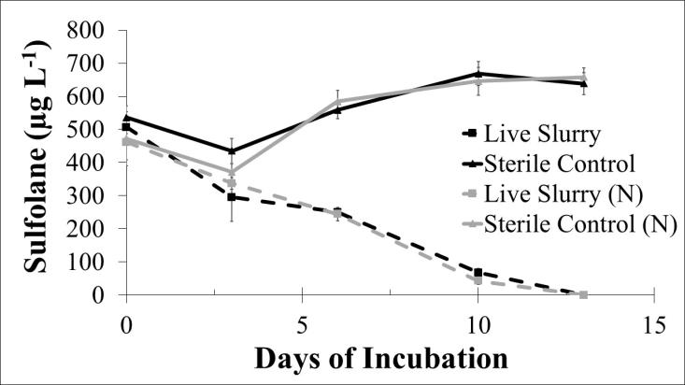

Figure 1: Sulfolane biodegradation in aquifer substrate microcosm studies. Live slurry indicates an active

microbial community. Sterile controls were heat killed. N indicates amended with a dilute mineral nutrient

solution. Incubation conditions were aerobic and 4 ˚C.

**Methods**

To date, hundreds of groundwater monitoring wells have been established throughout the

area of contamination in North Pole, AK to monitor sulfolane concentration changes in the

groundwater. Contractors working for Flint Hills Refinery conduct quarterly groundwater

sampling campaigns on these monitoring wells. We obtained 1 L of groundwater from 137 wells

during the 2013 fourth quarter sampling campaign and 37 wells during the 2014 first quarter

sampling campaign. Each 1 L sample was filtered through a 0.22 μm filter to capture

microorganisms in the water. A DNA extraction was then performed on the bacteria trapped on

each filter and the extract was sent for sequencing using next generation sequencing

technologies (Illumina MiSeq). The target region on the DNA was the 16S rRNA gene, which is

a bacterial gene useful for phylogenetic analyses. Other water samples were obtained from an experimental air sparge system where oxygen was injected into the aquifer through eight wells. 1 L of water was obtained from monitoring wells surrounding this system. Additional water samples were obtained from granular activated treatment systems that are used to filter sulfolane out of household drinking water. Samples from four biodegradation microcosm studies were obtained and the DNA was extracted using a Mobio Powermax DNA extraction kit. The microcosm samples contained soil and groundwater and were not filtered unlike the groundwater samples described above.

The V4 region of the 16S rRNA gene was amplified using Illumina fusion primers as described by Caporaso et al. PCR output for all samples was normalized using a Life Technologies SequalPrep Normalization plate. The normalized products were pooled. After Ampure clean up, QC and quantitation the pool was loaded on a standard v2 MiSeq flow cell and sequenced in a 2x250bp format using custom V4 sequencing and index primers (see Caporaso et al.) and a MiSeq 500 cycle reagent cartridge (v2). Base calling was done by Illumina Real Time Analysis (RTA) v1.18.54 and output of RTA demultiplexed and converted to FastQ with Illumina Bcl2fastq v1.8.4. FastQ files were QA/QC checked using Mothur (Schloss et. Al.) and taxonomically identified using the Silva Silva Seed V119 reference database. In order to reduce the dataset to a manageable size OTU’s that did not make up 0.01% of the population were excluded from downstream analysis. Multiple Response Permutation Procedure (MRPP) was conducted to determine community variability among sample groups. Pairwise comparisons were conducted between each group after the MRPP found significant differences. All statistical analyses were conducted using R statistical computing software (R 2015).

At the same time that samples were collected for microbial analyses during the quarterly

groundwater sampling campaigns, corresponding aquifer geochemical parameters were also

recorded, e.g. pH, temperature, dissolved oxygen, nitrate, sulfolane concentration, and many

other properties that may be important drivers of microbial community structure and function.

All geochemical data are stored on a data-sharing website and will be analyzed in relation to

groundwater microbial community structure data (based on 16S rRNA sequencing) using

multivariate statistical analysis methods. This comparison allows for the identification of

environmental parameters driving the microbial community structure, including diversity and

relative abundance of specific taxa.

**Results/Discussion:**

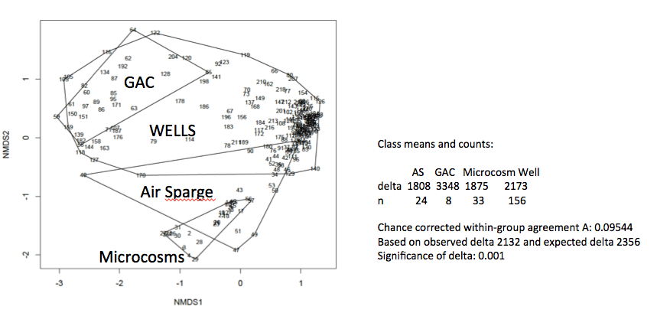

Figure 1: NMDS plot of MRPP data showing community differences between sample groups

Sample location was determined to be a driving factor of community structure based on MRPP analysis (Figure 1). Sample group explained roughly 10% of the community variability. Although there were similarities between microbial communities (Figure 2), pairwise comparisons of the sample groups revealed that all groups were significantly different from each other. Since each of these groups are different from each other, the next step in data analysis is to analyze the community in each sample group independently and attempt to correlate community structure with environmental variables.

Figure 2: Normalized graph of microcosm microbial community data at the phylum level.

A *Ralstonia Sp.* was the most abundant OTU in the entire data set and represented approximately 8% of the total community (Table 1). A representative sequence for this OTU was compared to the NCBI BLAST database. Out of the 675 Ralstonia species in the database this OTU was 98% similar to *Ralstonia insidiosa,* a common soil bacteria whose name refers to the fact that these seemingly harmless environmental organisms can be isolated from, and possibly cause infections in humans. Other abundant phyla also were not surprising given the sample location. Bacteria had a much higher relative abundance than Archaea (Table 2). This finding is in line with other prokaryotic assessments of environmental samples. Although primer bias and replicated gene copies in the same organism may be skewing the data it is likely that Archaea make up much less of the microbial biomass in this system. Future work using 13C labeled sulfolane will be conducted to identify exactly which members of the microbial community are involved in sulfolane biodegradation.

Table 1: Ten most abundant bacterial OTU’s

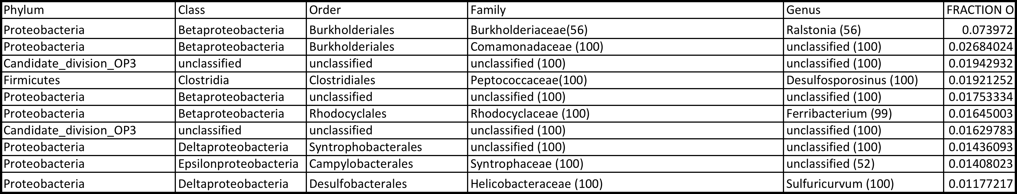

Table 2: Five most abundant Archaea OTU’s



**References:**

Agatonovic, V. and E. Vaisman., 2005. Sulfolane impacted soil and groundwater treatability

study. EBA Engineering Consultants, Ltd. and University of Calgary Tomographic Imaging and

Porous Media Laboratory.

Amann, R.I., Ludwig, W., Scheidler, K.H. (1995). Phylogenetic identification and in situ detection of individual microbial cells without cultivation. FEMS Microbiol. Rev. 59, 143–169

Caporaso, J. G., Lauber, C. L., Walters, W. A., Berg-Lyons, D., Lozupone, C. A., Turnbaugh, P. J., et al. (2011). Global patterns of 16S rRNA diversity at a depth of millions of sequences per sample. Proceedings of the National Academy of Sciences, 108 Suppl 1, 4516–4522. doi:10.1073/pnas.1000080107

CCME. 2006. Canadian soil quality guidelines for the protection of environmental and human

health: sulfolane. Canadian Environmental Quality Guidelines

Kozich JJ, Westcott SL, Baxter NT, Highlander SK, Schloss PD. (2013): Development of a dual-index sequencing strategy and curation pipeline for analyzing amplicon sequence data on the MiSeq Illumina sequencing platform. Applied and Environmental Microbiology. 79(17):5112-20.

Luther, S.M., Dudas, M.J., & Fedorak, P.M., 1998. Sorption of sulfolane and diisopropalamine

by soils, clays, and aquifer materials. Journal of Contaminant Hydrology. 32, 159-176.

Neufeld, J.D., Vohra, J., Dumont, M.G., Lueders, T., Manefield, M., Friedrich, M.W., Murrell,

J.C. (2007). DNA stable-isotope probing. Nature Protocols. 2(4), 860-866.

Prosser, J.I., Bohannan, B.J.M., Curtis, T.P., Ellis, R.J., Firestone, M.K., Freckleton, R.P.,

Green, J.L., Green, L.E., Killham, K., Lennon, J.J., Osborn, A.M., van der Gast, C.J., Young,

P.W. (2007). The role of ecological theory in microbial ecology. Nature Reviews Microbiology. 5,384–392.

R version 3.2.1 (2015-06-18) -- "World-Famous Astronaut" Copyright (C) 2015 The R Foundation for Statistical Computing Platform: x86_64-apple-darwin10.8.0 (64-bit)

Thompson, C.M., Gaylor, D.W., Tachovsky, A., Perry, C., Carakostas, M.C., & Haws, L.C.,

2013. Development of a chronic non cancer oral reference dose and drinking water screening

level for sulfolane using benchmark dose modeling. J. Appl. Toxicol. 33, 1395-1406.